* **What is Lambda in aws?**

AWS Lambda is a serverless compute service from [Amazon Web Services (AWS)](https://aws.amazon.com/lambda/features/) that allows you to run code without provisioning or managing servers. It enables you to execute code in response to events, automatically manages the underlying compute resources, and scales up or down based on demand.

In this article, we’ll explore AWS Lambda, its key features, pricing structure, and practical use cases.

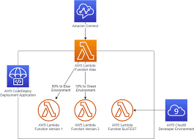

**Note ->**We can create lambda using different types of language

(like java , python, etc) but in this we use **python** language.

Steps for Creating AWS Lambda Functions Using AWS Console

1. Login into aws console management.
2. Create function.
3. Create test event & running code.
4. Creating bucket.
5. Add s3 bucket as triggered.

# **Lab Steps**

## **Task 1:Sign in to AWS Management Console.**

1. Search aws console management in chrome.

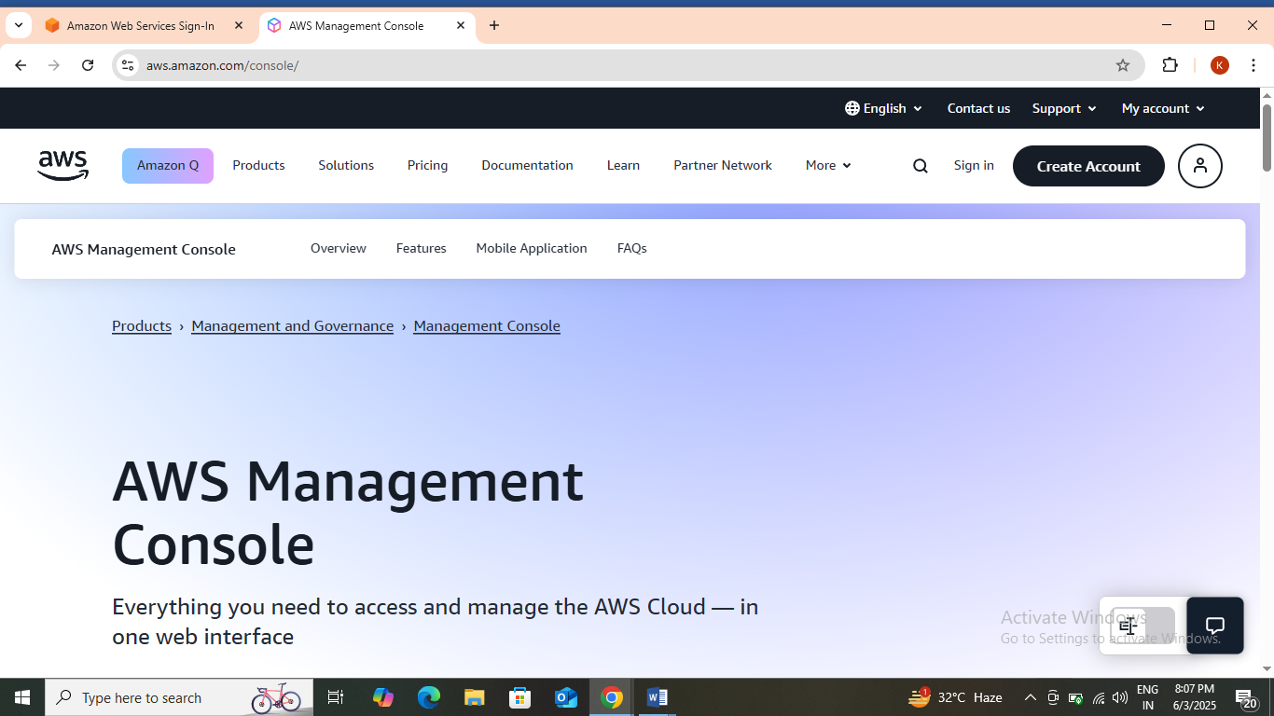

1. Then click on sign in. Now On the AWS sign-in page,

* Leave the Account ID as default. Never edit/remove the 12-digit Account ID present in the AWS Console. Otherwise, you cannot proceed with the lab.
* Now copy your **Username** and **Password** in the Lab Console to the **IAM Username and Password** in AWS Console and click on the **Sign-in** button.

1. Once Signed In to the AWS Management Console, make the default AWS Region as **Asia pacific(Mumbai) ap-south-1.**

**Task 2:Create Function.**

1. Make sure you are in the **Asia pacific(Mumbai) ap-south-1** Region before proceeding with the Lab.
2. Navigate to **Lambda** by clicking on the **Services** menu in the top, then click on **Lambda** in the **Compute** section.
3. In the left navigation menu, scroll down to **Functions**and click on **Create Functions** button.

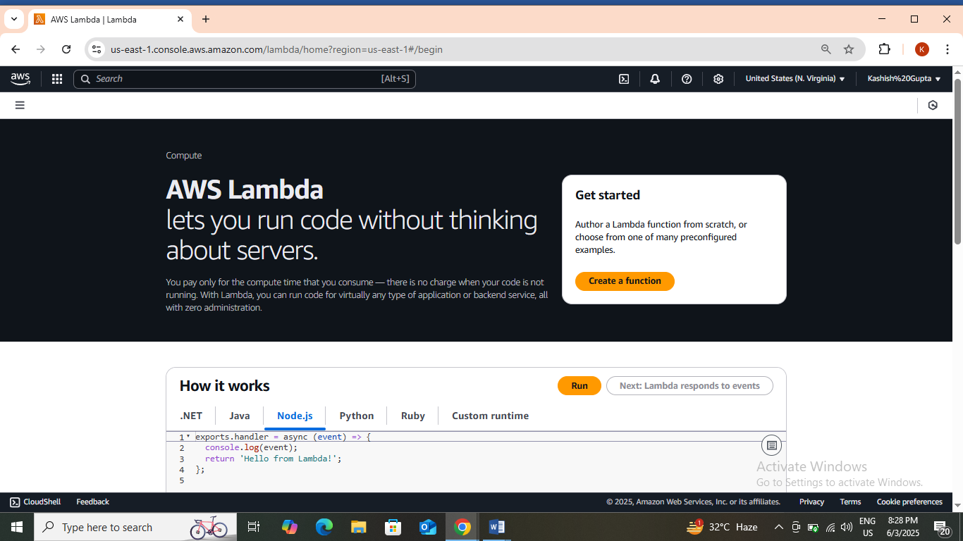

1. Choose **Author from scratch.**
2. Enter function name – **mylambdafunction.**
3. In runtime, select – **Python3.13.**

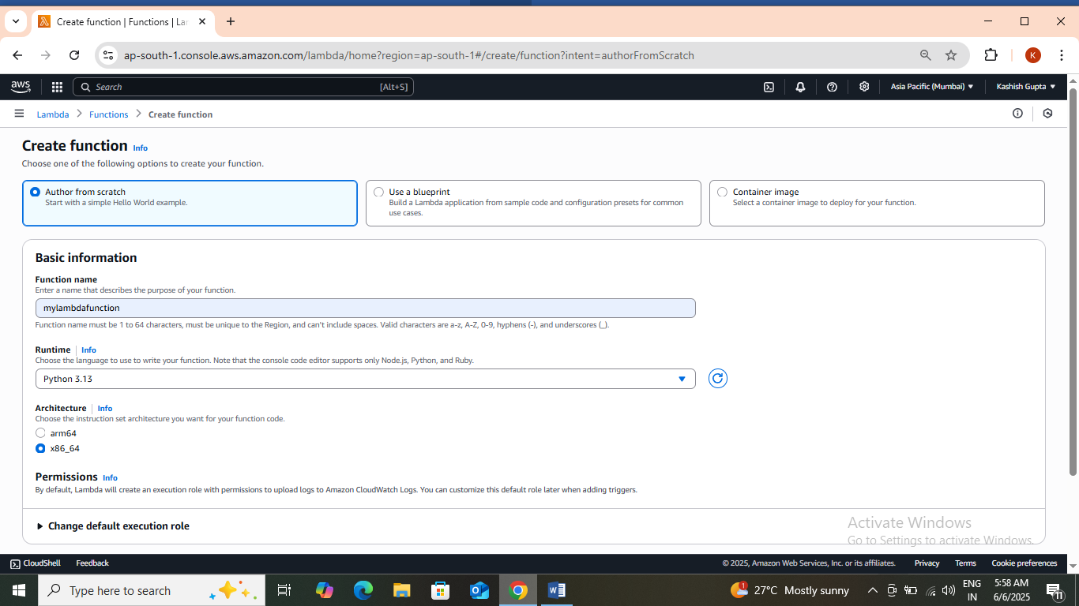

1. Keep all the settings as default.
2. Now, click on **create function** and your function is created.

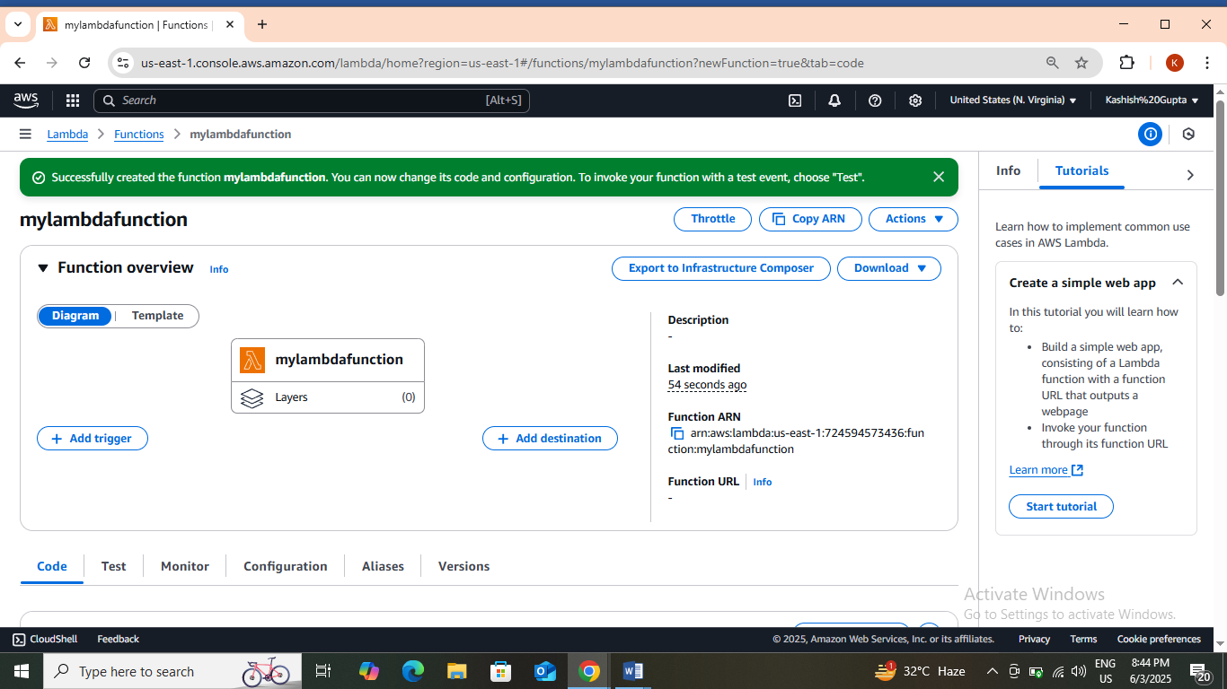

**Task 3:**Create test event & running code.

1. Now scroll down and the code is written there.

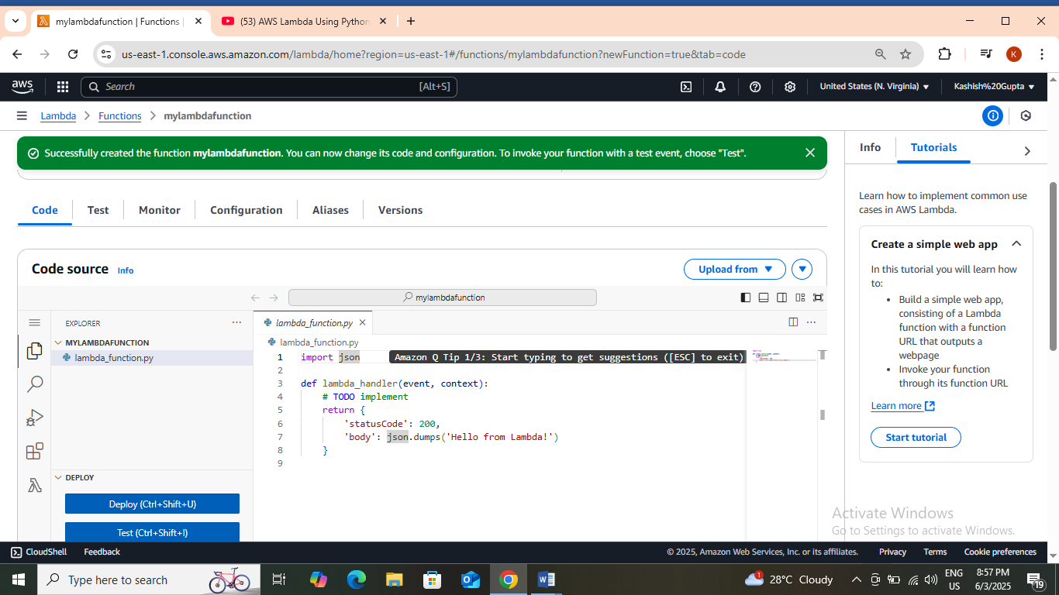

1. Now, you can run this code by clicking on **test**or press **ctrl+shift+i**.
2. When you click on test then this will show, which means you don’t have any test event right now.

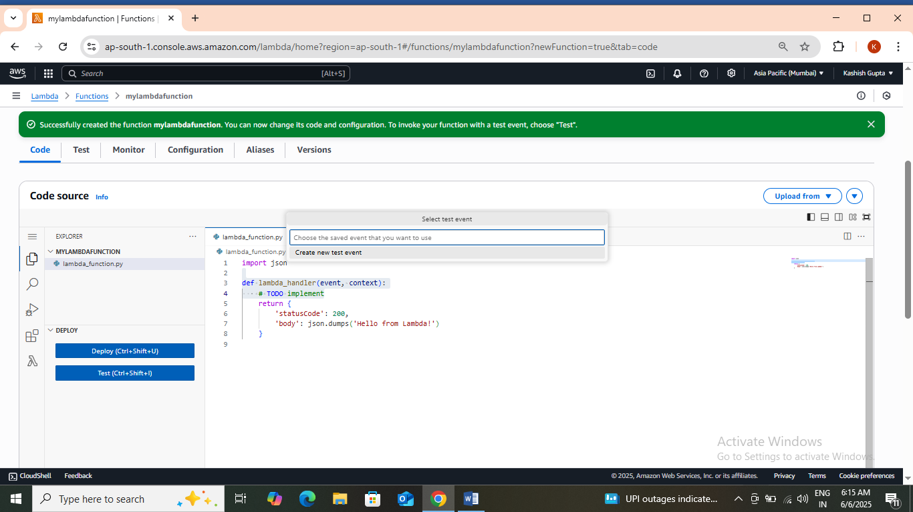

1. **Creatingnewtest event.**Click on **test.**

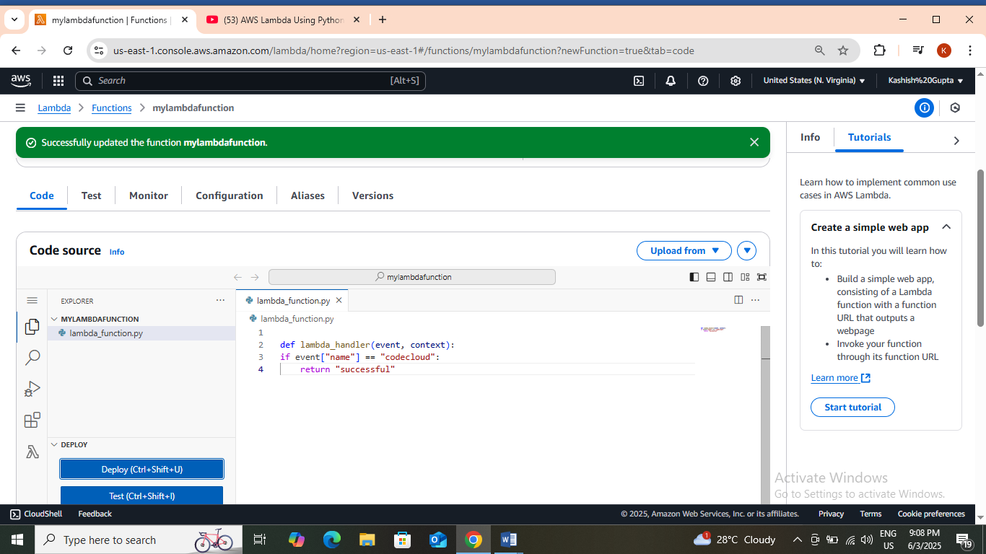

1. Select **create new event.**
2. Enter event name- **mytestevent**.

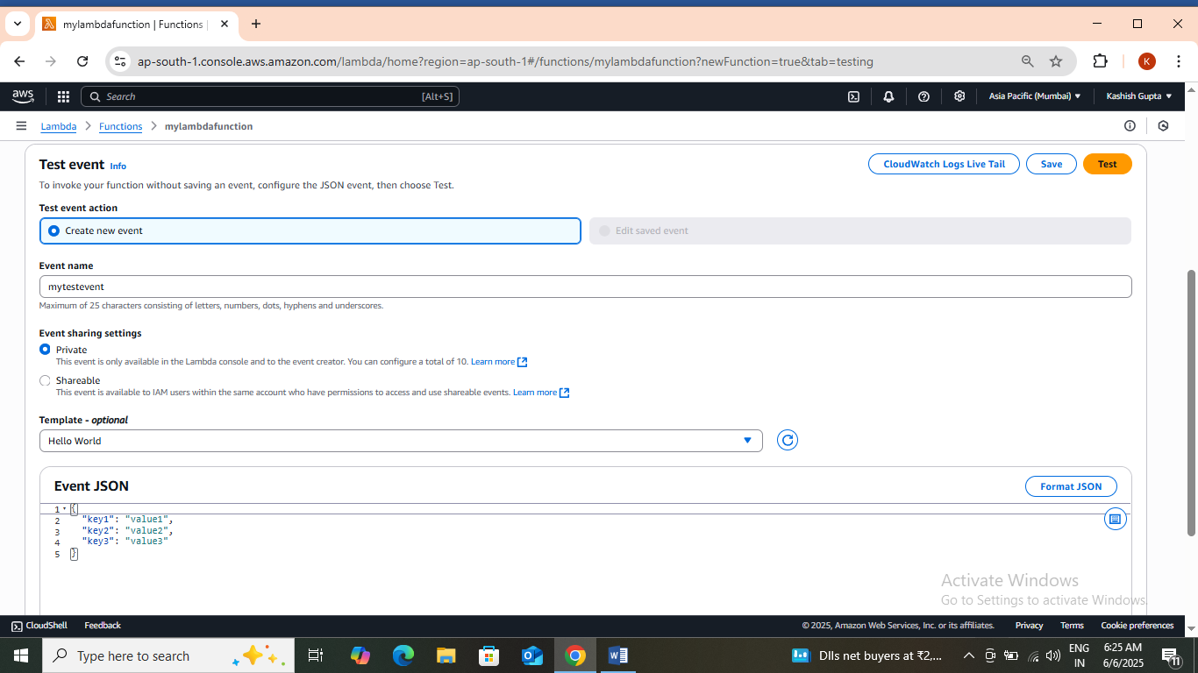

1. Now click on **save.**
2. And then click on **test.** Then go to code again and press **ctrl+shift+i**. Then your output is ready and it will look like this.

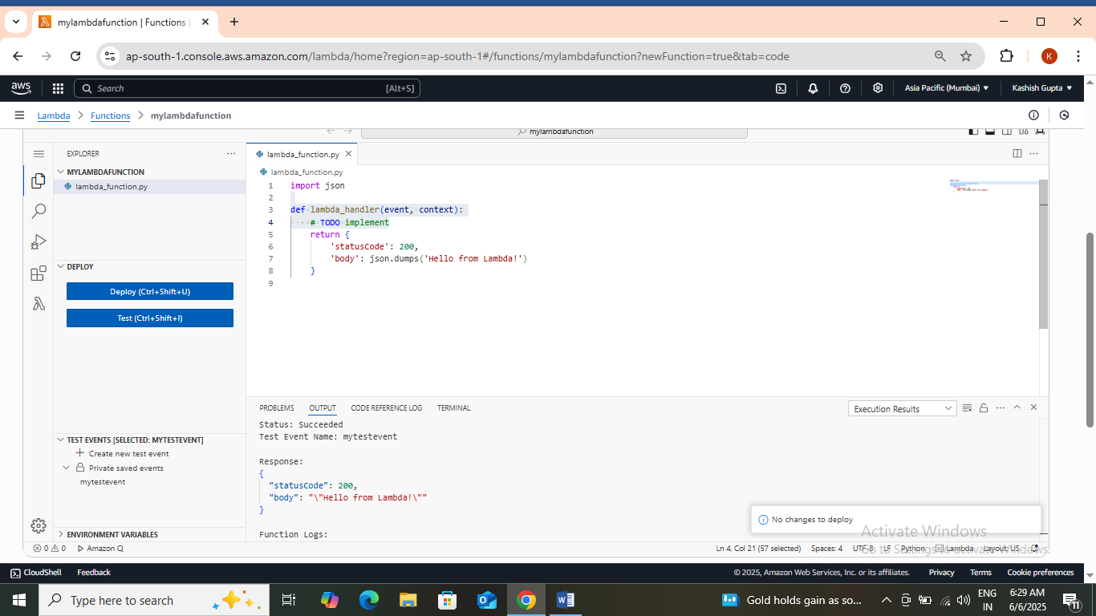

**Task 4:**Create Bucket.

1. Navigate to **AWS** **S3** by clicking on **Services** in the top left corner. S3 is available under **Storage**.
2. In the S3 dashboard, click on the **Create Bucket**button and fill in the bucket details.

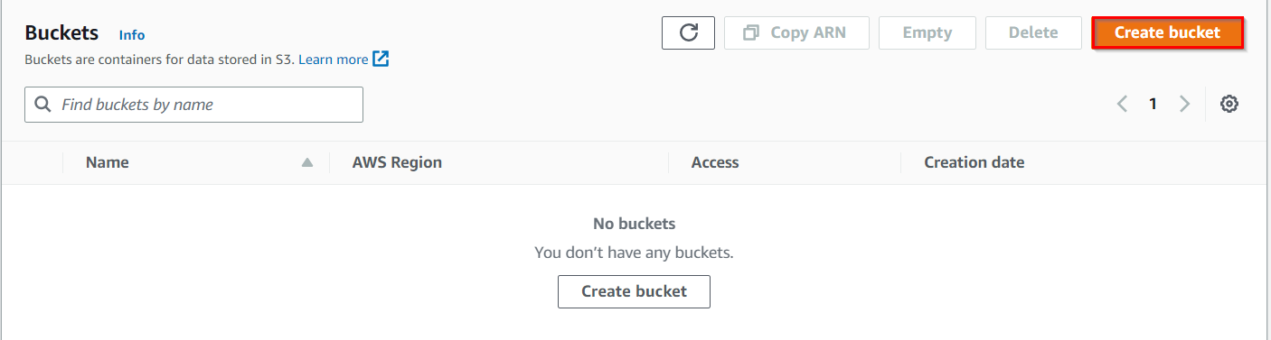

1. In the **General Configuration**:
   * Bucket name: Enter **myawsbucket6-06-2025.**
   * Example **: *mys3buckettestingsns-sam***  
     (**Note:**The Bucket Name must be unique across all existing bucket names in Amazon S3)
   * Region: Select **Asia pacific(Mumbai) ap-south-1.**

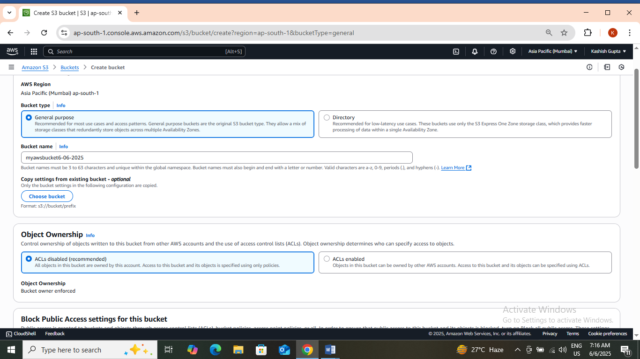

1. Object ownership: Select **ACLs disabled (recommended)** option.
2. Leave all other settings as default and click on **Create bucket**.
3. And add upload any file in the bucket by clicking on the bucket name.

**Task 5:Add s3 bucket as triggered.**

1. Go to lambda function and then click on add trigger written on left side.
2. After clicking on add trigger, go to Trigger configuration:
   * Select : **S3**
   * Now select the bucket which you have created in s3 .
   * In recursive innovation – **Check the box.**

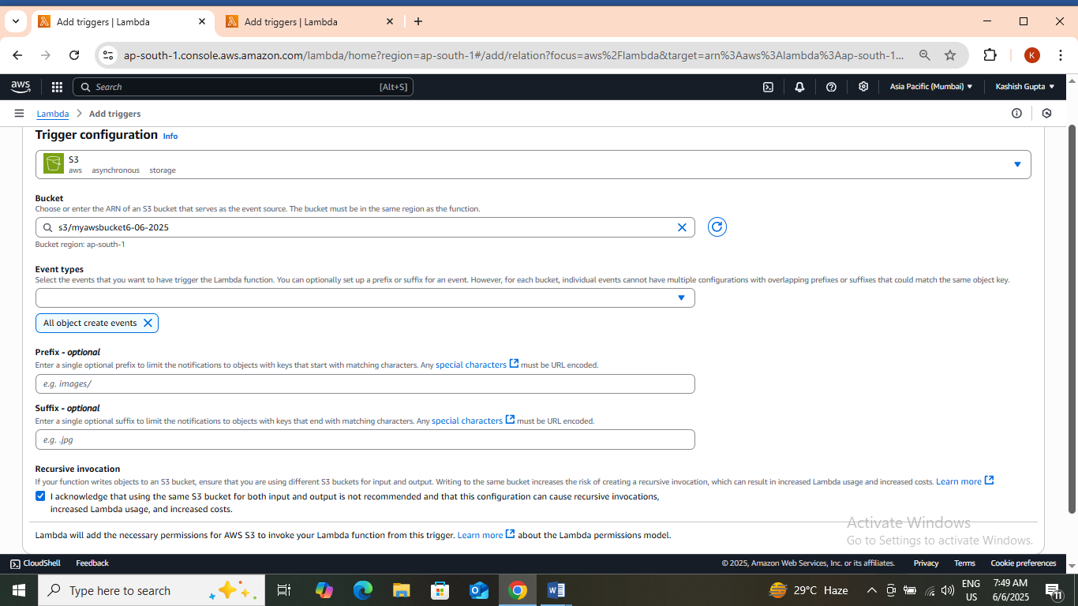

1. Then click on add.

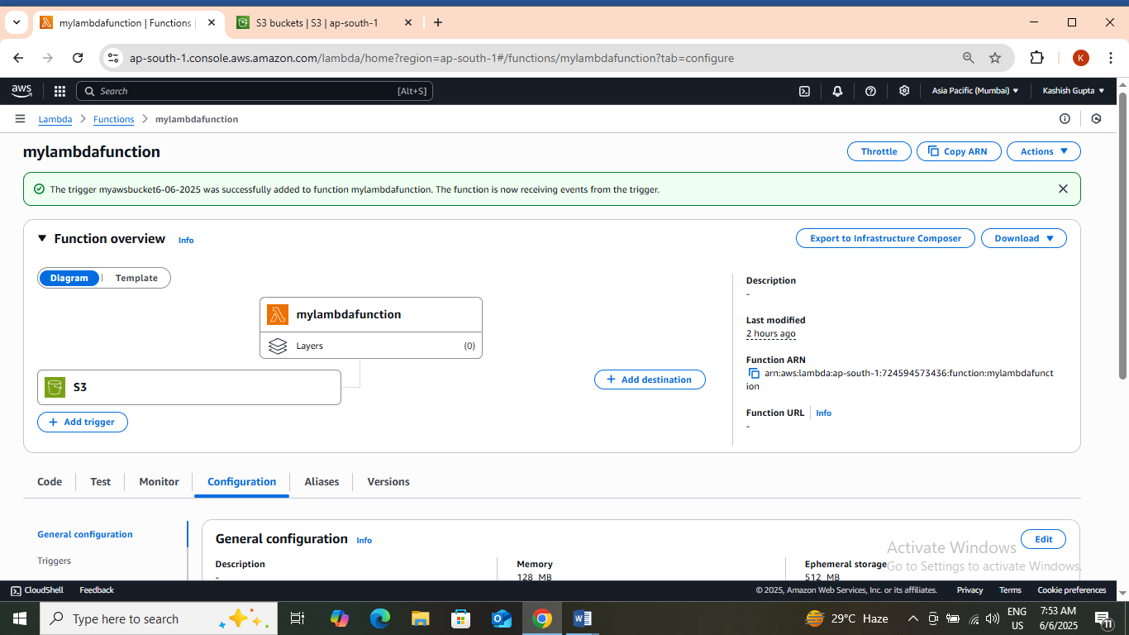

1. Now scroll down and go to configuration and then click on permissions.

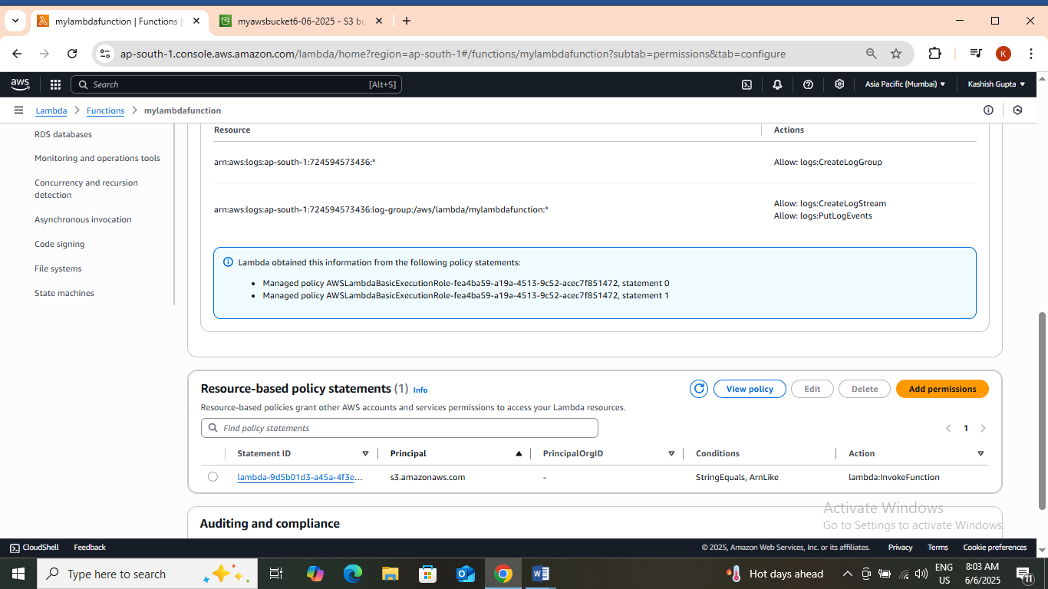

1. You can see that one resource policy is already created.
2. You can also check by clicking on the bucket name and then click on **properties**. In this you can see that event notification is also created.

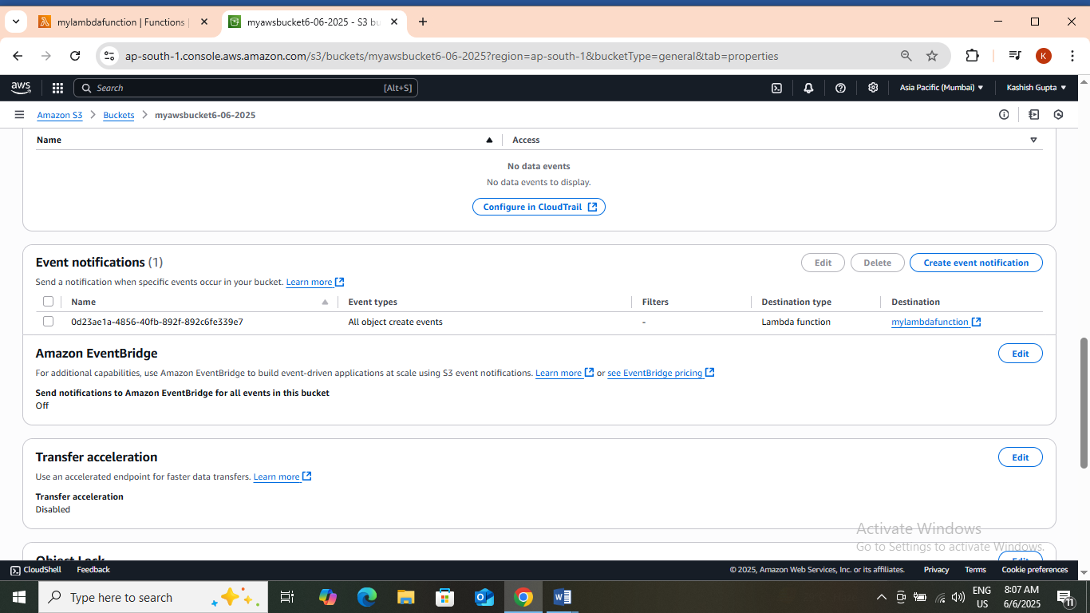

1. **Now you can say that your lambda function is working properly. You can also check this by uploading .zip file in code and then run that code .**
2. **In last step firstly delete the upload file and then bucket after that delete the trigger and lastly delete the function and then sign out from your aws account.**